9
…
Sarah Jaar
Lujain Hamdan
Anas Abu-Humaidan

Taxonomy
- It’s the ordering of organisms in organized and related groups according to their characteristics.
- Identification, classification and nomenclature are three separate but interrelated areas of bacterial taxonomy. Each area is critical to the ultimate goal of accurately studying the infectious diseases and precisely communicating these to others in the field.
- Bacterial taxonomy depends on our knowledge about the structure, metabolism and genetics of bacteria.

- Classification is the categorization of organisms into taxonomic groups using biochemical, physiologic, genetic and morphologic properties.
- Taxonomic ranks are: kingdom, division, class, order, family, genus, species and subtype.
- What defines a species is the ability to reproduce and give fertile offspring. But there is no definitive “species" taxon in bacterial classification due to:
- Asexual reproduction.
- Horizontal gene transfer.

- Identification is the practical use of a classification scheme to:
- isolate and distinguish specific organisms among the mix of complex microbial flora.
- verify the authenticity or special properties of a culture in a clinical setting.
- isolate the causative agent of a disease and identify it. This leads to the selection of specific pharmacologic treatments (e.g. antibiotics).
- This area of microbiology is necessarily dynamic as the tools continue to evolve (e.g. new methods of microscopy, biochemical analysis and computational nucleic acid biology).

- Nomenclature refers to the naming of an organism according to scientific rules, so each name refers to the same organism and is understood by all scientists, microbiologists, physicians, etc.
- This is arguably the most important component of taxonomy because it allows medical professionals to communicate with each other. Any professional associated with an infectious disease should be aware of the evolving taxonomy of infectious microorganisms.
Classification
Bacteria can be classified according to:
- Macroscopic and microscopic appearance (morphology)
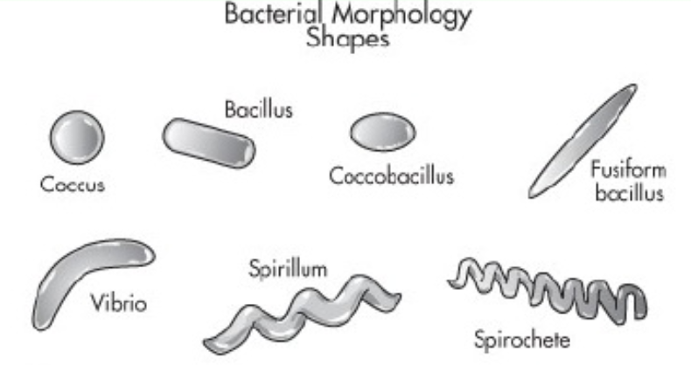
It’s the first step in identification because it’s simple and needs few minutes. To determine the morphologic characteristics, we stain the bacteria then examine them under the microscope.
- The shape:
- Cells can have different shapes: Coccus, Bacillus, Spirillum, Vibrio, etc.
- Many cells can form clusters, chains or pairs.

- Staining Reactivity:
- Depending on the bacterial structure, they can be classified according to:
- Gram stain reactivity. They can be:
  - Gram-negative: appear pink/red after staining (with Gram stain).
  - Gram-positive: appear purple/blue after staining (with Gram stain)
- Acid-fastness; they are either acid-fast or non-acid-fast.
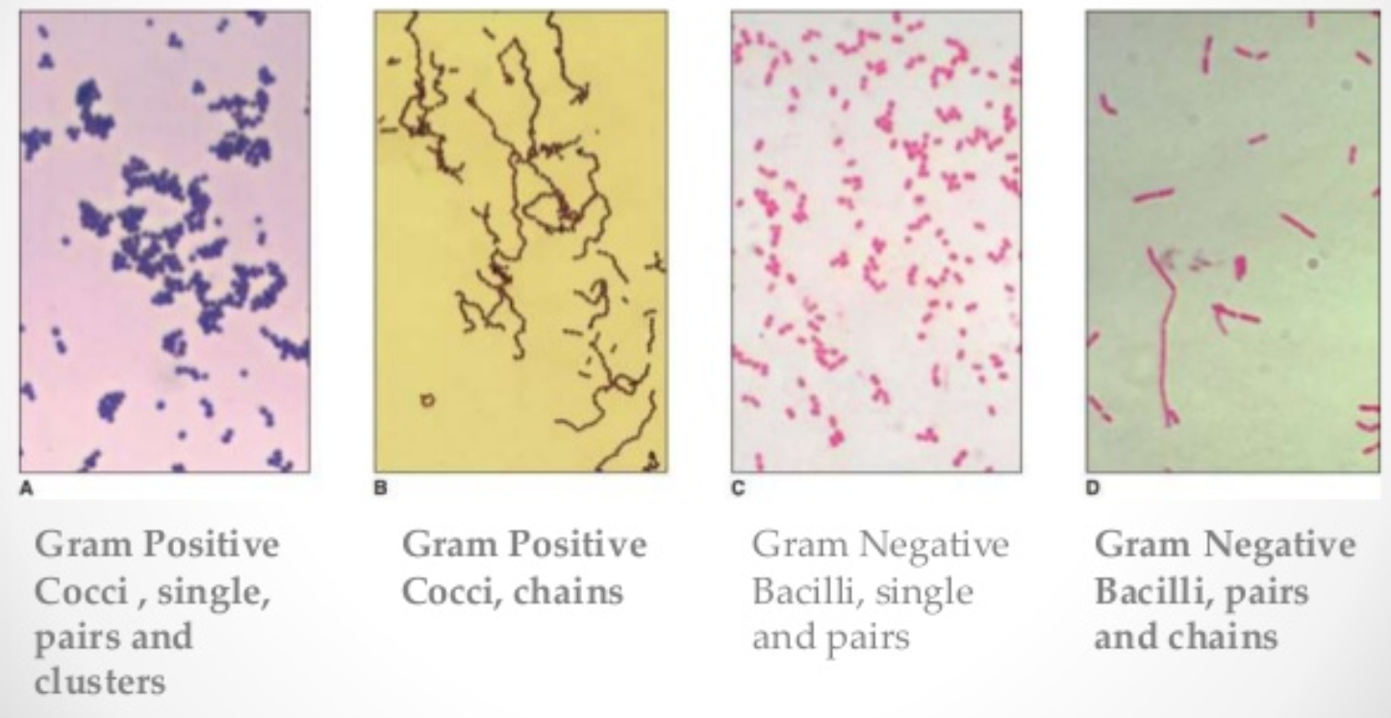

- Motility: can be detected by the SIM (Sulfide (H₂S) Indole motility) medium test. SIM is generally used to differentiate Enterobacteriaceae members.

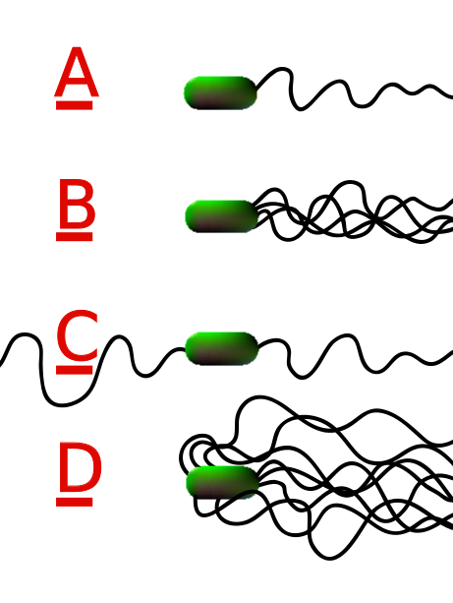
- Flagella organization:
- Flagella are not seen under the light microscope since they’re very thin, but a special stain can deposit inside them making them visible under the microscope.
- A bacterium can have one flagellum, a pair or a lot of flagella.
- They can also be organized on one pole, two poles or circularly distributed.

- Colony Characteristics on agar plates (growth media) after a specific time:
- Colonies' shape can be flat or raised, and can have a large or small surface area.
- Also, a colony can be smooth, rough or mucoid.
- Colonies have different colours with different opaqueness. This helps microbiologists in identification.
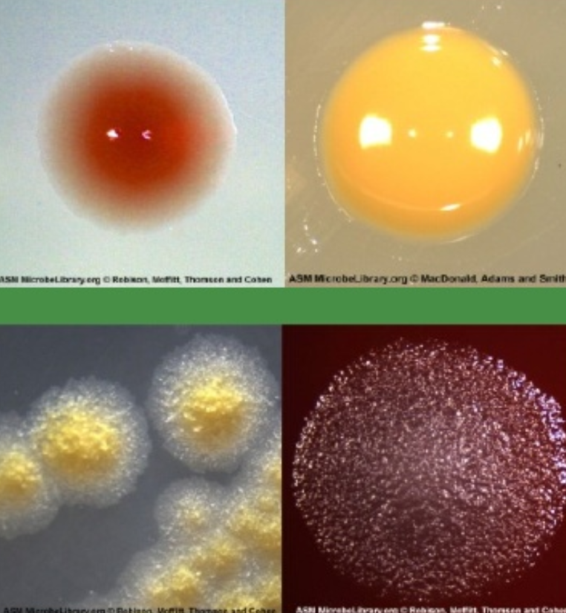
- Remember that each cell in the colony is similar to the original cell.
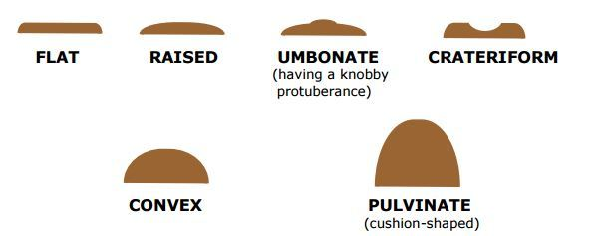

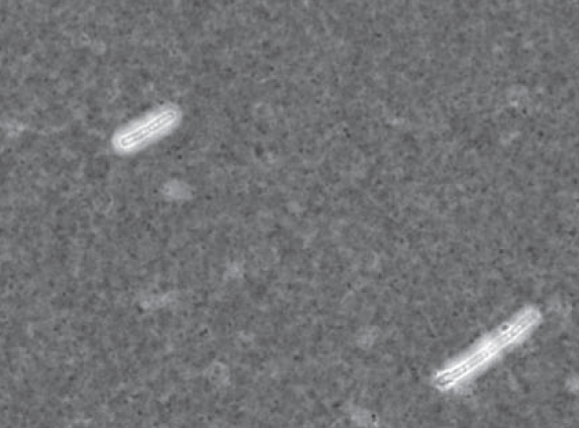
- Presence of pores, capsules or inclusion bodies:
- The Capsule stain: the unstained (translucent) region in the picture to the right represent the capsule of the bacterial cell.

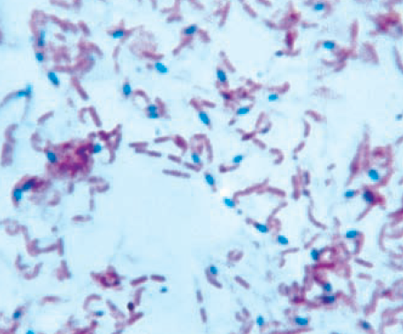
- The Spore stain: Additional info: Spores are most simply observed as intracellular refractile bodies in unstained cell suspensions or as colourless areas in cells stained by conventional methods. The spore wall is relatively impermeable, but dyes can be made to penetrate it by heating the preparation. This same impermeability then serves to prevent decolourisation of the spore during a period of alcohol treatment sufficient to decolorize vegetative cells. The latter (vegetative cells) can finally be counterstained. Spores are commonly stained with malachite green or carbolfuchsin.

- Growth conditions

  - Oxygenation:
- If the bacteria are aerobic: the culture's size increases during oxygenation.
- If the bacteria are facultative: the cells can survive and grow with or without oxygen.
- If the bacteria are anaerobic: the culture's size decreases during oxygenation due to the formation of oxygen radicals (toxic byproducts) and the inability to eliminate them, resulting in cell death.
- Actually, these free radicals are formed in aerobic and facultative bacteria as well, but those bacteria have certain enzymes that can detoxify these radicals like: catalase, peroxidase and superoxidase dismutase. So H₂O₂ and other radicals will be converted to oxygen or water (nontoxic).
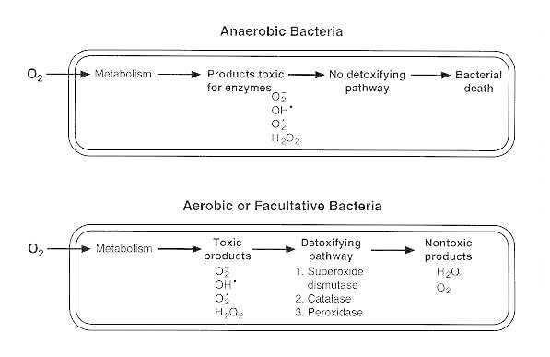

  - Type of medium used: Because some bacteria need special nutrients.
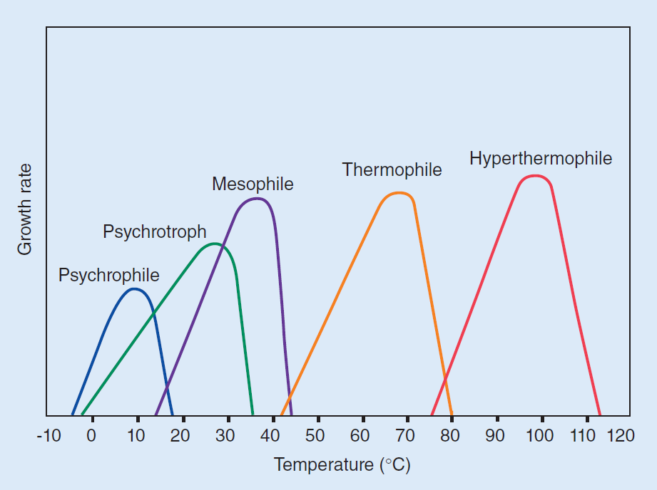
  - Temperature: Thermobacteria (thermophilic bacteria) have a high optimal temperature, while most of bacteria have an optimum temperature in the range of 30-40 °C.

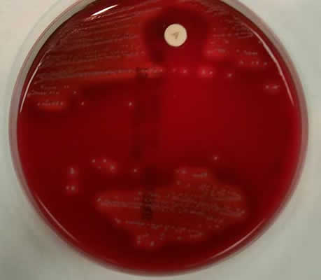
  - Antibiotic sensitivity: It depends on the type of medium and helps in differentiating between bacteria within similar groups. If a clear ring is formed in the agar plate after using an antibiotic, this means that specific bacterium is sensitive to that type of antibiotic. The yellow disc in the image to the right was infused with antibiotic.

  - pH

- Biochemical characteristics
They help classify and identify bacteria according to their metabolic and enzymatic properties.
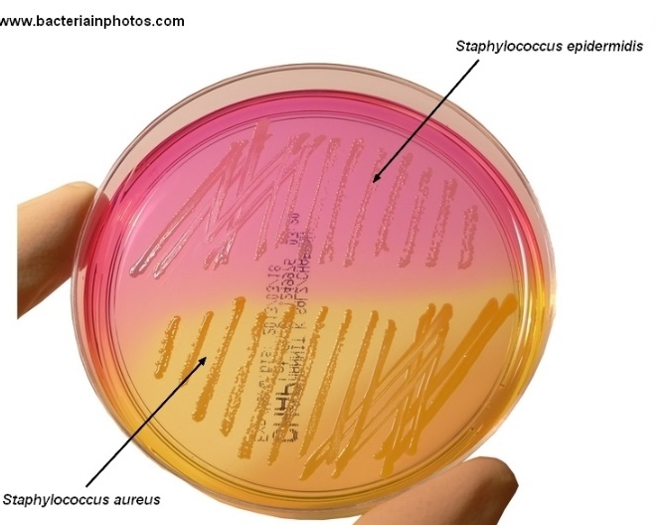
Carbohydrates breakdown/utilization:
- Such as in mannitol-salt agar (MSA) plates. If the bacteria (e.g. Staphylococcus aureus) can metabolize the mannitol within the agar plate and produce acidic byproducts, the colour of the plate changes to yellow because the medium contains pH indicator.

- The non-pathogenic Staphylococcus epidermidis can grow on MSA plate but can’t utilize mannitol, so colour remains pink-red.
- The MSA can be both selective or differential. It is selective since it mostly allows only Staph. bacteria to grow, and is differential since it can differentiate between Staph. aureus and epidermidis.
Catalase production:
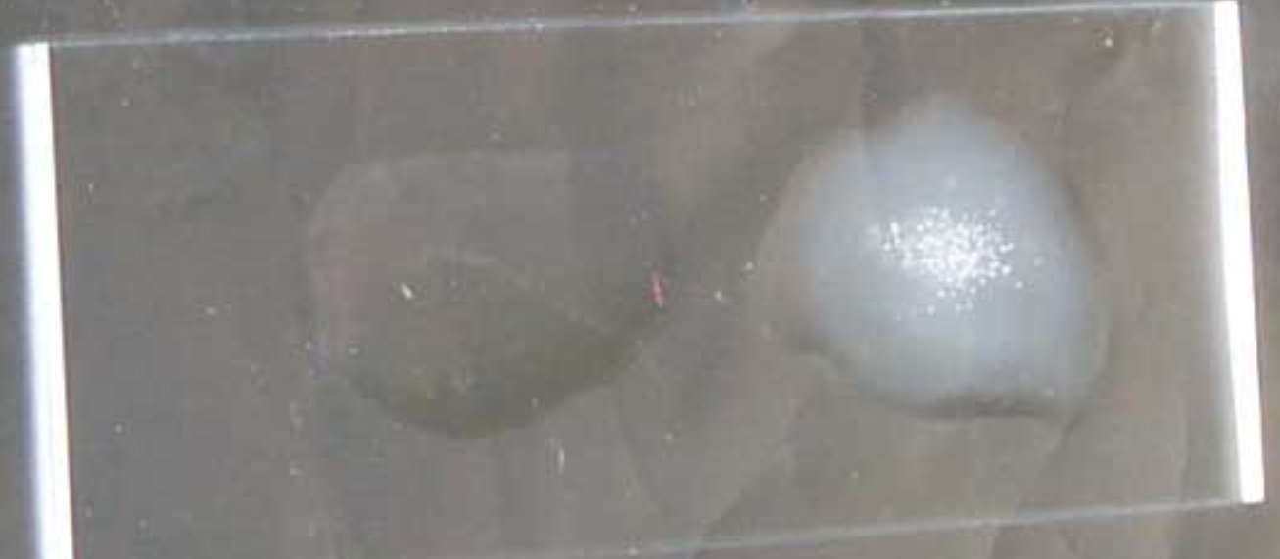
- The enzyme catalase catalyses the conversion of hydrogen peroxide to water and oxygen. When a colony is placed in hydrogen peroxide, liberation of oxygen as gas bubbles can be seen.
No catalase Catalase present
- We add H₂O₂ to the bacteria samples that we want to investigate; if we notice formation of bubbles in the sample (sample becomes frothy), these bacteria produce catalase.
Coagulase production:
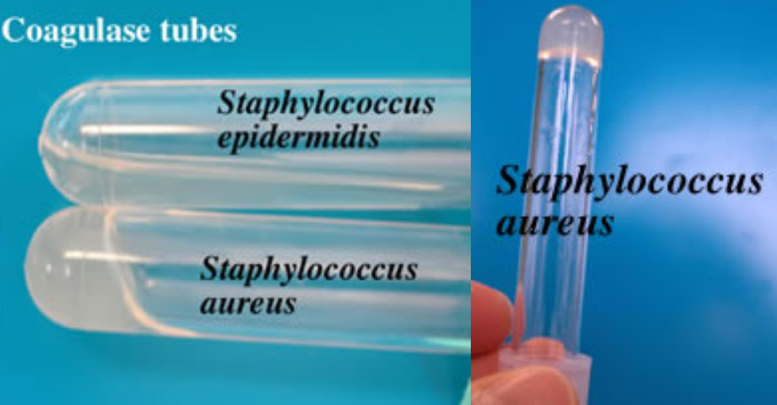
- The enzyme coagulase acts with a plasma factor and converts fibrinogen to a fibrin clot. It is used to differentiate Staph. aureus from other less pathogenic Staphylococci (e.g. Staph. epidermidis).
- In a tube with liquid plasma, we add Staphylococcus aureus; the result is coagulated plasma because Staphylococcus aureus produce coagulase. Then if you flip the tube plasma doesn’t move.

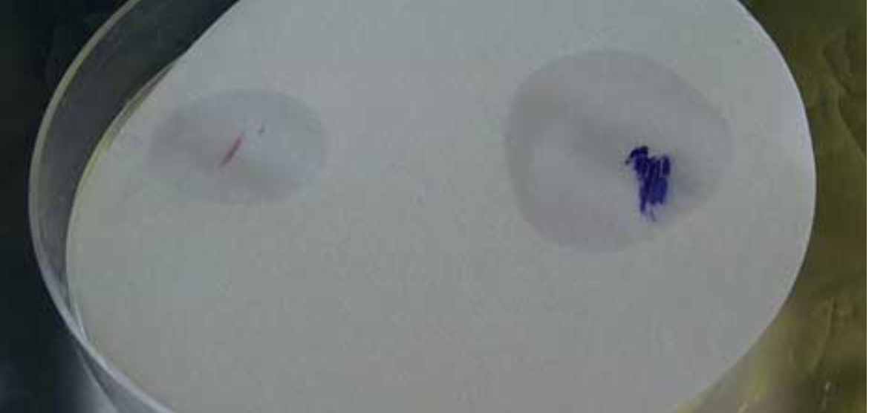
Oxidase production:
(Additional information): The oxidase tests detect the c component of the cytochrome–oxidase complex. The reagents used change from clear to coloured when they are converted from the reduced to the oxidized state.

Hemolysis in blood agar (differential medium):
- Bacteria differ in the patterns that they form in hemolysis.
- Also, we can add antibiotic disk to detect the antibiotic sensitivity.
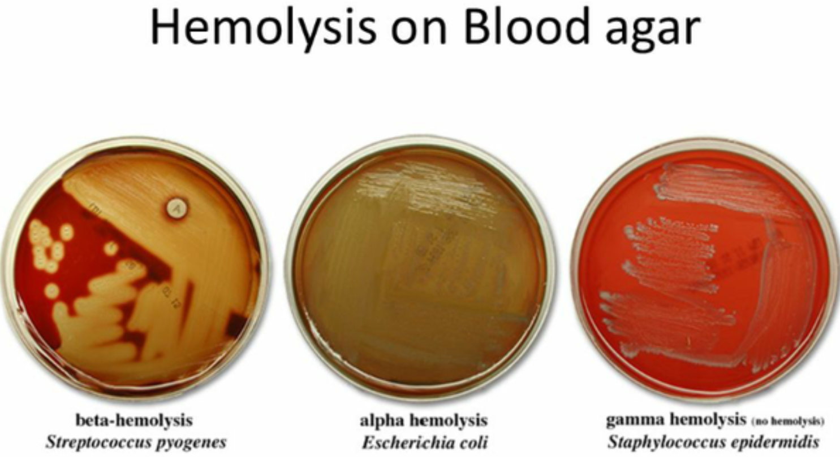
SIM medium:
- Detects multiple characteristics at the same time: H₂S gas formation, indole presence and motility.
- Stab sample of bacteria into solid agar in a test tube then observe changes.
- Indole-positive bacteria are detected by the formation of a red layer after addition of benzaldehyde reagent.
- H₂S is formed from sulphur-containing compounds like amino acids. The black colour of the sulphide salts formed with heavy metals such as iron is the usual means of detection of H₂S-positive bacteria.
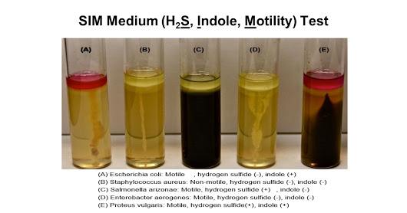
- Motile organisms extend from the stab line and produce turbidity or cloudiness throughout the medium. Non-motile organisms grow only along the stab line and leave the surrounding medium clear.

- Antigenicity
- Genotype
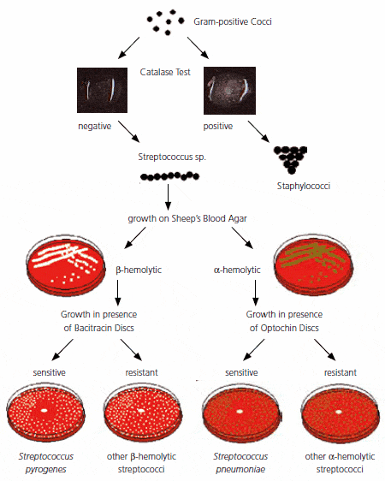
Then we gather all these criteria that we have examined to create an algorithm or a key. (Notice these two figures).

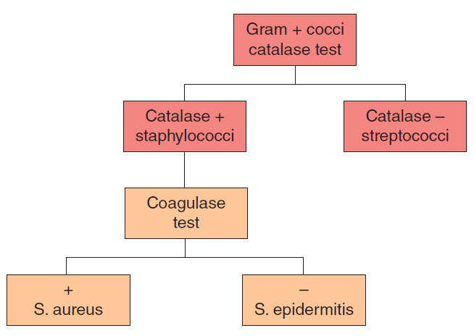

Numerical taxonomy
- It’s a static system used to identify a known bacterium or classify bacteria in similar groups.
- It can’t be used for newly discovered bacteria.
- For numerical taxonomy we use a strip with around 20 compartments and each compartment reveals a different biochemical criterion.
- We add a drop of our bacterial sample in each container.
- We give a number to each reaction that occurred.
- Then we confirm those numbers to a sheet (database) or insert them into a computer to know what is the most possible organism that gives this pattern of numbers.
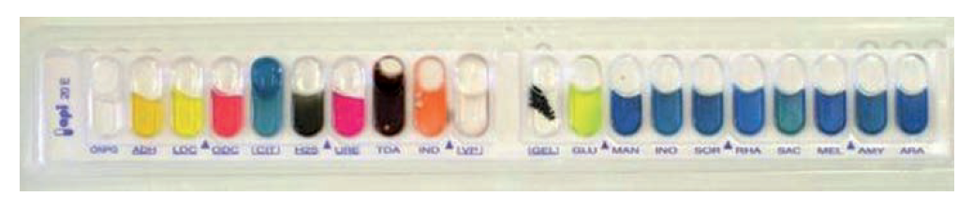
- When this approach is the only basis for defining a species, it is difficult to know how many and which tests should be chosen; whether and how the tests should be weighed; and what level of similarity should be chosen to reflect relatedness at the genus and species levels.

Bergey's Manual of Systematic Bacteriology
A good manual has grouped bacteria that classify each bacterium according to different criteria. First published in 1923, this publication taxonomically classifies, in the form of a key, known bacteria that have or have not been cultured or well described.
Until now there’s no definitive classification for bacteria!
In the table on the following page you find many groups of bacteria that cause infectious diseases (not for memorising! Just to notice the classification and description of bacteria).
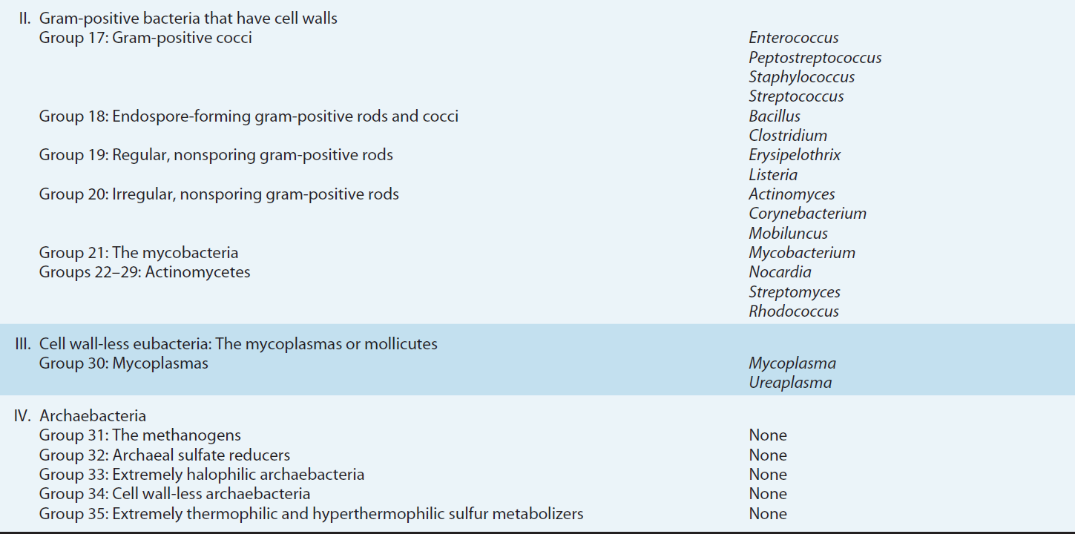
Subtyping
- It’s a taxonomic rank at the subspecies level, because bacteria can have different characteristics even within the species itself.
- It’s important in epidemiological studies.
- To classify bacteria in subtypes, usually we can depend on immunological reactions in a method called serotyping which depends on immunological activity.
- In serotyping we use antibodies that react with specific bacterial structures because they have specific recognizable macromolecules that work as antigens, like:
- Capsule antibody reacts with K antigen.
- Cell wall (LPS) antibody reacts with O antigen.
- Flagella/fimbriae antibody reacts with H antigen.

- Example: E. coli O157:H7 subtype causes severe, acute haemorrhagic diarrhea.
- Example: V. cholerae O1 and O139 serogroups are associated with epidemic and pandemic cholera.
- Other methods can be used for subtyping:
- Chemical Fingerprint: using mass spectrometry.
- Genetic Makeup: using DNA sequencing.
- In classification or subtyping, we use the method that is suitable for the purpose of that and depending on the facilities that are present.

Emerging Tools
Nowadays, in tertiary hospitals in Sweden, they use a technique called:
Matrix associated laser desorption ionization-time of flight mass spectrometry (MALDI-TOF). It’s used for microbial identification and strain typing.
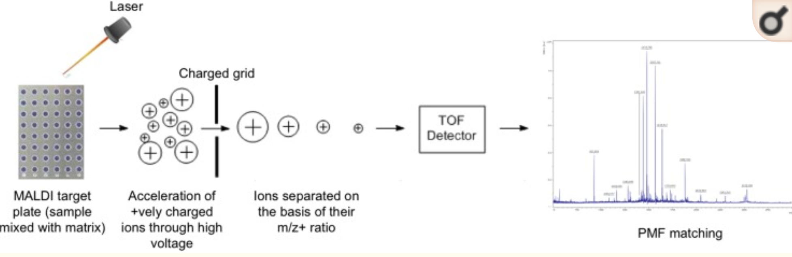
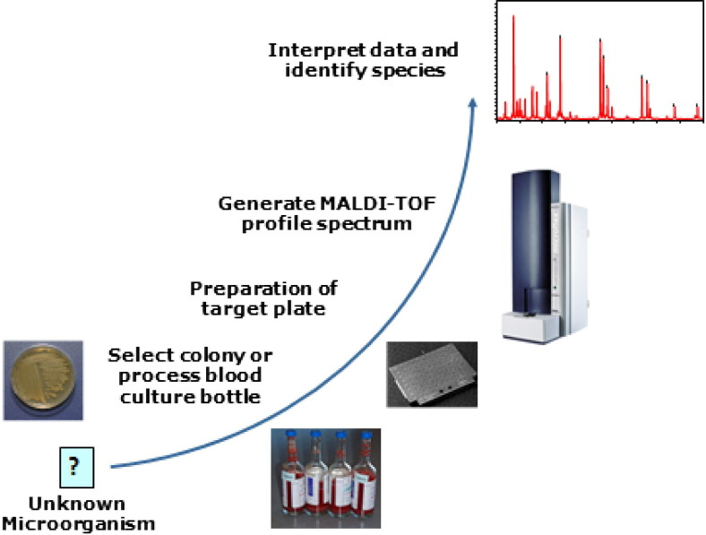
In MALDI-TOF mass spectrometry, protein or peptide samples are mixed with a matrix and dried onto a metal sample plate. After the plate is placed in a high vacuum source chamber in the mass spectrometer, a small portion of the sample is vaporized (desorption) by blasts from a nitrogen laser. The ions produced ‘fly’ up a tube to the mass analyser and their masses (actually their mass-to-charge ratio) are determined by their ‘time-of-flight’.

Phylogenetic Studies
- Genetic relatedness between different types of bacteria can be done using several methods that investigate homology in nucleic acids.
- These methods can be: DNA hybridisation, DNA sequencing, and polymerase chain reaction (PCR) amplification.
- Ribosomal RNA:
- Ribosomes have an essential role in protein synthesis for all organisms. Genetic sequence encodings ribosomal RNAs (rRNA s16) and ribosomal proteins (both of which are required to comprise a functional ribosome) have been highly conserved throughout evolution and have diverged more slowly than other chromosomal genes since ribosomes are essential for bacteria survival.
- The phylogenetic tree below is based on rRNA data, which shows the three major domains of biological life as they are currently understood.
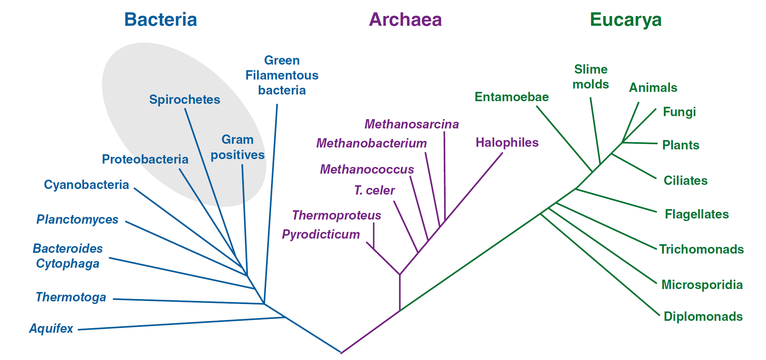
- From this diagram, two kingdoms- eubacteria (true bacteria) and the archaebacteria- are distinct from the Eukaryotic branch.
- Many organisms have multiple copies (five to seven) of these genes, resulting in patterns with a sufficient number of bands to provide good discriminatory power; however, ribotyping is of limited value for some microorganisms, such as mycobacteria, which have only a single copy of these genes.

DNA hybridization
It’s done by the technique of Southern blot analysis by these steps:
- DNA molecule is extracted from the bacteria that we want to compare with each other.
- The separated fragments are transferred to a nitrocellulose or nylon filter.
- These double-stranded DNA fragments are first converted into single-stranded linear sequences.
- Using a labelled fragment of DNA as a probe, it is possible to identify the restriction fragments containing sequences that are homologous to the probe by complementation to the bound single-stranded fragments.
If there’s more than 70% hybridisation, we can say the bacteria belong to the same species. 25-70% hybridisation indicates same genus but different species. If there’s less than 25% hybridisation, they’re considered to be of different genera.
** Labelling can be done by using radioactive atoms in the labelled molecule.
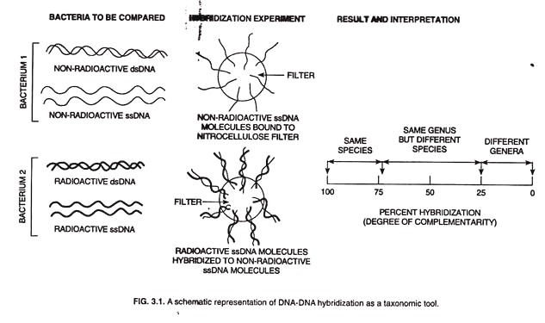
Cytosine + Guanine content (Genomic Analysis)
- There is considerable genetic diversity among bacterial species. Chemical characterization of bacterial genomic DNA reveals a wide range of nucleotide base compositions among different bacterial species. One measure of this is the guanine + cytosine (G + C) content. Scientists found that bacteria clustering groups are related by the C+G content. If the G+C content of two different bacterial species is similar, it indicates taxonomic relatedness.
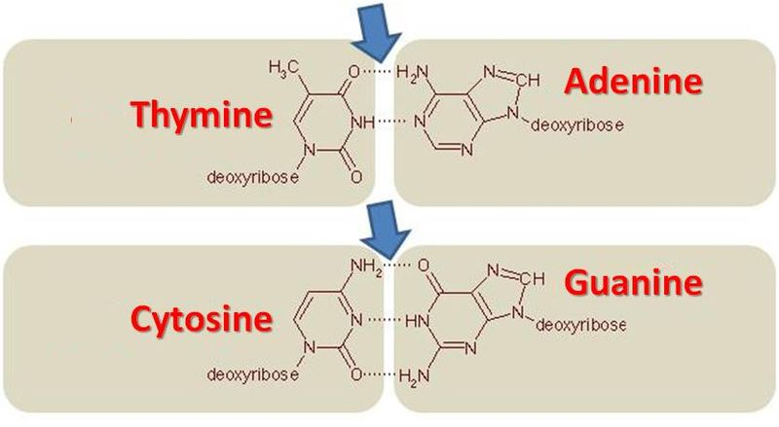
- C+G content can be known by measuring the energy that’s needed to break the strands. The DNA with higher C+G content will require a higher temperature.
- Remember that each cytosine forms three hydrogen bonds with each guanine.

